Assignment #3

* I downloaded the subject thumbdrive image and tools from Prof Ervin’s OneDrive Account.
* The downloads included: the FTK Imager, Quick Stego, and Marco’s thumbdrive.
* Once they were downloaded, I began the installation of the tools.
* Once installed I opened the FTK Imager and added a new evidence item and using an image file as the Source Evidence Type.
* I chose the file that our professor provided to us.
* Once opened, I began my search of a potential deleted file.
* I was going through each directory to see if a file had an X. Meaning that it was previously deleted.
* I went into the root directory then went through each directory within root which were folders with cities names.
* Everything was good until I got to the “Hawaii” directory. Inside that directory file I noticed that it contained 3 more folders. I inspected the “Kauai” and discovered that the deleted folder was there.
* The deleted folder is called !Ians. Inside that directory there was a file called !SC2858.BMP.

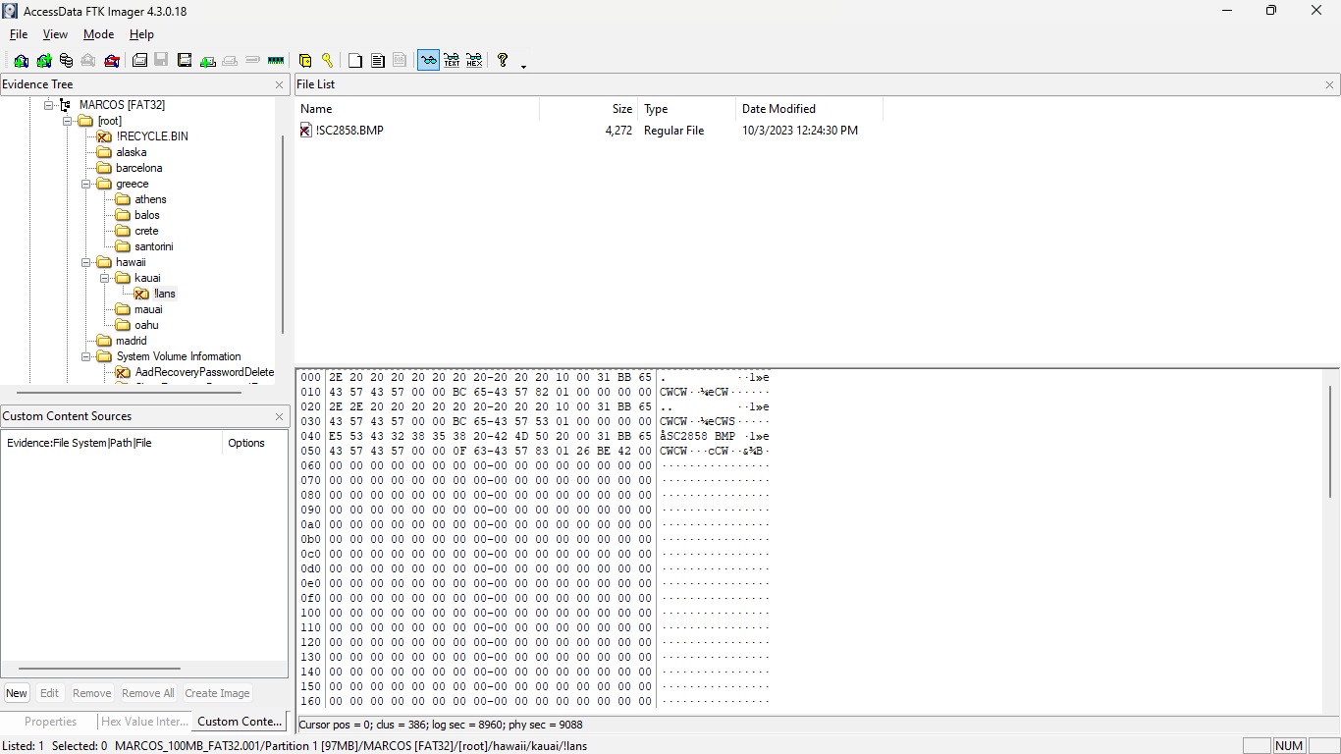

* Since I know that the .bmp extension is used for steganography I went ahead and opened Quick Stego.
* I imported the !SC2858.bmp file and the details of the next attack were discovered.

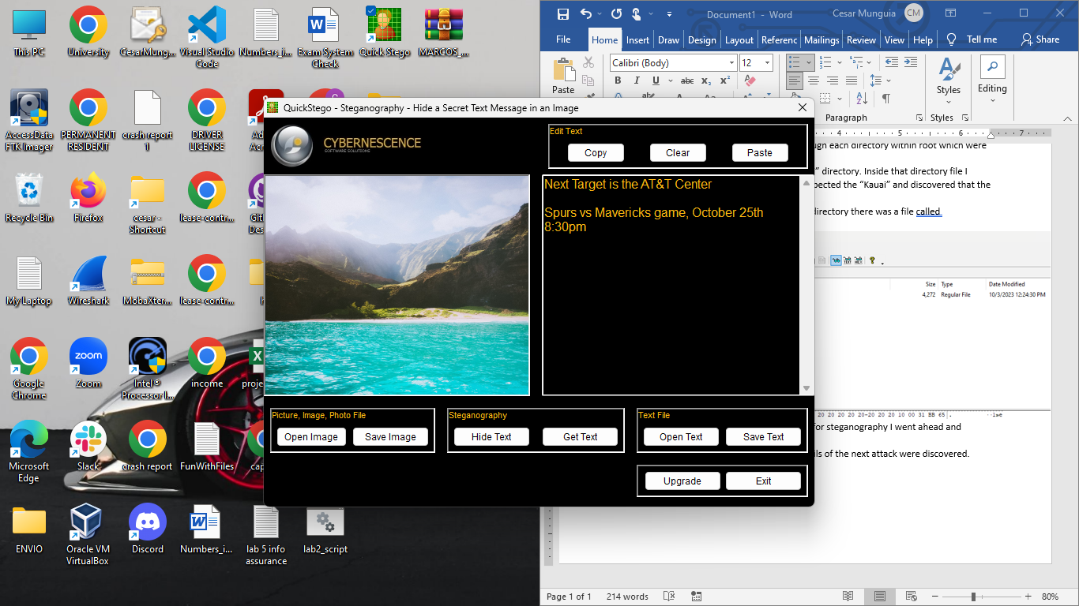

* The message said: “Next Target is the AT&T Center … Spurs vs Maverick game, October 25th 8:30pm”

BONUS:

* I created a disk image of my 2nd drive in my computer.

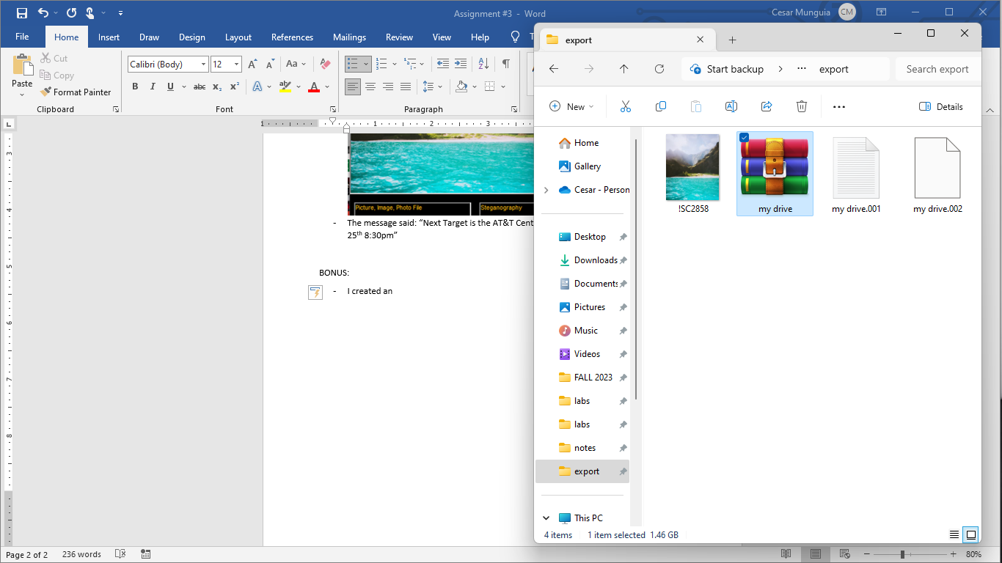

* I included the my drive.001 file which contains all the details about the drive.
* I opened the my drive file as new evidence.

